Council assessment Report
Panel Reference | PPSSWC-11
DA Number | 2117/2019/DA-DE
LGA | Campbelltown City Council
Proposed Development | Proposed Community Recycling Centre
Street Address | Lot 104 DP 1056782, Hepher Road, Campbelltown
Applicant/Owner | Campbelltown City Council – Applicant  Campbelltown City Council – Owner
Date of DA Lodgement | 1 July 2019
Number of Submissions | No submissions received
Recommendation | Approval
Regional Development Criteria (Schedule 4A of the EP&A Act) | Schedule 7 of SEPP (State and Regional Development) 2011 identifies Designated Development Applications (including waste management facilities or works) as being regionally significant development.  As a result, the Development Application has been referred to the Sydney West Planning Panel for determination.
List of All Relevant s4.15(1)(a) Matters | - Environmental Planning and Assessment Act 1979  - Environmental Planning and Assessment Regulation 2000  - Water Management Act 2000 & Water Management (General) Regulation 2018  - NSW Biodiversity Conservation Act 2016  - State Environmental Planning Policy 33 – Hazardous and Offensive Development  - State Environmental Planning Policy (Infrastructure) 2007  - State Environmental Planning Policy (State and Regional Development) 2011  - State Environmental Planning Policy 55 - Remediation of Land  - State Environmental Planning Policy (Vegetation in Non-Rural Areas) 2017  - State Environmental Planning Policy 19 – Bushland in Urban Areas  - State Environmental Planning Policy 44 – Koala Habitat Protection  - Greater Metropolitan Regional Environmental Plan No. 2 –Georges River Catchment  - Campbelltown Local Environmental Plan 2015  - Campbelltown (Sustainable City) Development Control Plan 2015
List all documents submitted with this report for the panel’s consideration | - Assessment report and conditions  - Environmental Impact Statement  - SEARs  - Flora & Fauna Assessment  - Aboriginal Assessment  - Preliminary Site Investigation Phase 1  - Architectural Plans  - Civil Drawings  - Erosion & Sediment Control Plan  - Landscape Plan  - Waste Management Details  - Arborist Report
Report by | Donna Clarke – Landmark Planning Pty Ltd
Report date | 20 May 2020

Summary of 4.15 matters  Have all recommendations in relation to relevant 4.15 matters been summarised in the Executive Summary of the assessment report? | Yes
Legislative clauses requiring consent authority satisfaction  Have relevant clauses in all applicable environmental planning instruments where the consent authority must be satisfied about a particular matter been listed, and relevant recommendations summarised, in the Executive Summary of the assessment report?  e.g. Clause 7 of SEPP 55 - Remediation of Land, Clause 4.6(4) of the relevant LEP | Yes
Clause 4.6 Exceptions to development standards  If a written request for a contravention to a development standard (clause 4.6 of the LEP) has been received, has it been attached to the assessment report? | No
Special Infrastructure Contributions  Does the DA require Special Infrastructure Contributions conditions (S94EF)?  Note: Certain DAs in the Western Sydney Growth Areas Special Contributions Area may require specific Special Infrastructure Contributions (SIC) conditions |  | No
Conditions  Have draft conditions been provided to the applicant for comment?  Note: in order to reduce delays in determinations, the Panel prefer that draft conditions, notwithstanding Council’s recommendation, be provided to the applicant to enable any comments to be considered as part of the assessment report | Yes

Executive Summary

The application proposes the following works:

- Construction of a building for use as a ‘Community Recycling Centre (CRC); and
- Associated infrastructure, car parking and landscaping.

The site is located centrally within an existing industrial estate and the portion of the site subject of this development is the higher land and located close to the adjoining industrial development to the north-west, at the end of the existing cul-de-sac. Hepher Road is accessed via an intersection at Johnson Road.

The site is owned by Campbelltown City Council.

The application was referred to Roads and Maritime Services (RMS) in accordance with Schedule 3 of the State Environmental Planning Policy (Infrastructure) 2007, who advised that they raise no objection as the proposed development is unlikely to have significant impact on the state road network.

Under Campbelltown Local Environmental Plan 2015, the subject site is zoned SP2 Infrastructure. The LEP defines the proposed use as a waste or resource management facility and since it does not explicitly permit the use of this site for the purpose of waste or resource management, it is a prohibited land use under the provisions of the local plan, However, the use is separately defined under Clause 121 of State Environmental Planning Policy (SEPP) (Infrastructure) 2007 and permits the use of SP2 Infrastructure zoned land for the purpose of waste or resource management. The SEPP prevails to the extent of any inconsistencies with the LEP and therefore the development is a permissible land use in the zone.

The application is Designated Development (under Schedule 3 of the Environmental Planning & Assessment Regulation 2000) and is a waste management facilities or works which are specifically identified as being regionally significant development and therefore in accordance with Schedule 4A of the Environmental Planning & Assessment Act 1979 (the EP&A Act 1979), is to be determined by the Sydney West Planning Panel. As the proposal is Designated Development, an Environmental Impact Statement (EIS) was prepared based on the Secretary’s Environmental Assessment Requirements (SEARs) issued by the Department of Planning and Environment on 19 September 2018.
The application is not deemed to be Integrated Development (under Section 91 of the Environmental Planning & Assessment Act 1979). Council Officers have contacted the EPA as part of the assessment who have advised that the application is not considered to be “Integrated Development” as the waste is only being stored on site then transferred off site. Council Officers have also contacted the Natural Resources Access Regulator as it involves works within 40 metres of an existing watercourse, who confirmed that a Controlled Activity Approval (CAA) is not required.

The cost of works proposed under the application is $480,000.

This application has been independently assessed given that the site is owned by Campbelltown City Council.

This application has been assessed against the provisions of Section 4.15 of the Environmental Planning and Assessment Act 1979. Having regard to these provisions, the application has been found to be satisfactory. The proposal has been found to satisfy the relevant State Environmental Planning Policies. In particular, pursuant to clause 7 of State Environmental Planning Policy 55 – Remediation of Land, information has been provided that demonstrates that the site is suitable for the proposed development. The proposal would also satisfy the relevant provisions of Campbelltown Local Environmental Plan 2015 and Campbelltown Development Control Plan 2015.

It is considered that the overall social and economic impacts of the proposed development would be positive, and that potential impacts on the natural and built environments will be mitigated through design measures and the imposition of specific conditions of consent. High quality landscaping is proposed around all sides of the building.

The application was publicly exhibited and notified to surrounding properties, and no submissions were received.

The site’s location, zoning and existing land use make it suitable for the proposed development, and the proposal is in the broad interests of the general public.

1. Application Overview

1.1 The Site and Locality

A site visit was carried out on 9 September 2019 by Council Officers and Donna Clarke of Landmark Planning.

The site is identified as Lot 104 DP 1056782, Hepher Road, Campbelltown. The site is irregular in shape with two components separated by the existing road. The site is located centrally within an existing industrial estate and the portion of the site subject of this development is the higher land and located close to the adjoining industrial development to the north-west, at the end of the existing cul-de-sac. Hepher Road is accessed via an intersection at Johnson Road.

The overall site has an area of approx. 7.45 ha, however the subject portion to be developed for the CRC has an area of approx. 3000m². The CRC will be sited on its own lot 5000m² in size which is being created through a separate development application.

The site is traversed by a number of watercourses, which are in the vicinity of the subject development area. The EIS details that “a Strahler fourth order stream crosses the footprint area of the proposed development, however, flood mapping and recent development suggest the stream no longer flows through the site. Historical aerial imaging indicates the subject site has been subject to significant levels of ground disturbance such as earth works and levelling.” The remainder of the site contains detention basins and is prone to flooding.

The overall site is generally cleared with the vegetation primarily contained in the subject development portion of the site, which includes heavy weed infestation. Two trees (identified as Trees T5 and T7 in the Arborist Report) will be removed to accommodate the development.

The Deposited Plan does not indicate the presence of easements on the subject lot, however, does make note of a covenant.

The industrial area is sited immediately to the south of the Hume Highway and as can be seen by the figures below, the nearest residence is approximately 300 m to the south west of the subject portion of the site.

The closest CRC is located at Liverpool, around 20 km from the proposed site.

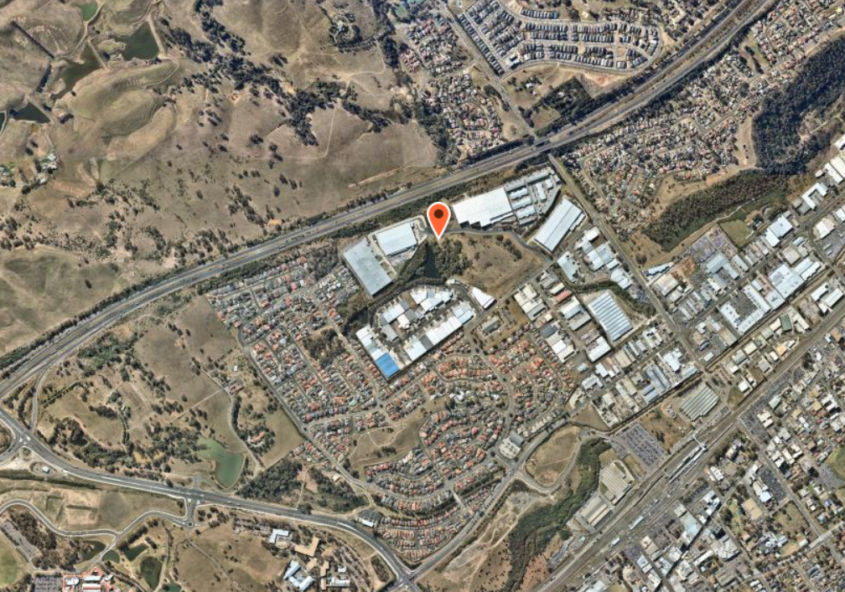
Figure 1: Locality Plan
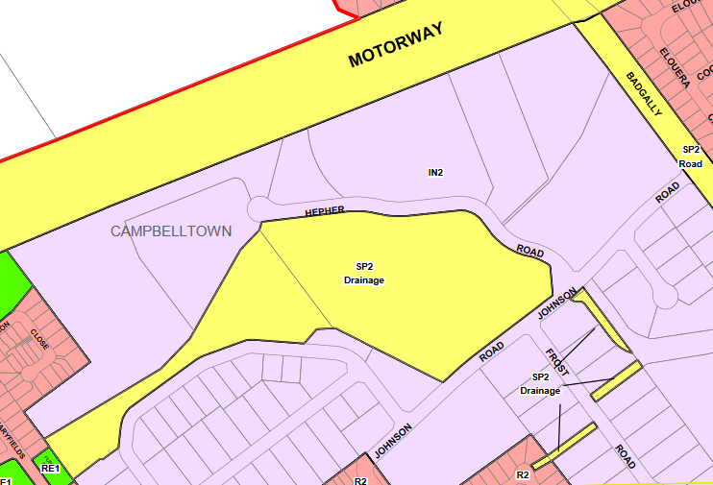
Figure 2: Zoning Map (location marked with star)

1.2 Proposal

The applicant has sought development consent for the construction of a Community Recycling Centre (CRC) that services the local community and would collect household waste materials that could potentially be hazardous to the environment.

The proposal specifically includes:

- A partly enclosed building for the receipt and temporary transfer of problem household wastes.
- One way sealed internal driveway access from Hepher Road, which operates as a separate entry and exit.
- Two (2) parking spaces adjacent to the office.
- Staff amenities.
- Proposed office/gatehouse.
- Connection to existing services including electricity, water and sewer and other civil infrastructure including stormwater drainage.
- Light poles along the internal driveway.
- Landscaping.
- Vegetation removal.
- Fencing around the facility to be secure from the remainder of the site.

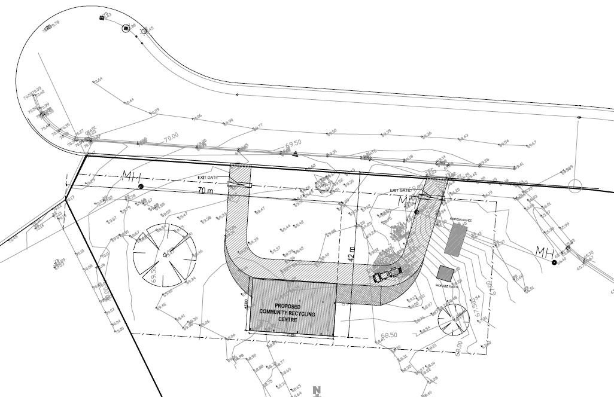
Figure 3: Proposed Site Plan

The application indicates that:

- The household waste materials include household quantities of paints, oils, batteries, gas cylinders, fluorescent light fixtures, and smoke detectors. These waste materials would be stored separately to avoid possible reactions between the materials and would be removed from site by contracted collectors for safe and proper disposal.

- The CRC is also expected to receive non-targeted by-catch materials, that is, materials that are not processed by the CRC. By-catch materials of flammable, oxidising, toxic, or corrosive nature are to be stored in Dangerous Goods Safety Cabinets and disposed of through the correct avenues.

- The CRC is expected to provide for a resident population of around 150,000 people and would be expected to receive around 450 tonnes of problem waste per year, of which around 213 tonnes is expected to be hazardous wastes. The residual would consist of other forms of problem waste, such as e-waste, which is not hazardous when intact.

Residents access the site in their private vehicle to dispose of the waste into the allocated bins and receptacles. Once full, these bins and receptacles are relocated to the rear of the site and transported off site for disposal.

The proposed vehicular crossover and driveway is to have a concrete finish and the parking spaces constructed of gravel. Fencing is proposed around the perimeter of the CRC, with separate dedicated entry and exit points.

The proposal includes clearing of remaining scattered existing vegetation and the applicant has advised that the siting of the CRC has avoided significant vegetation on the overall site. Two trees (identified as Trees T5 and T7 in the Arborist Report and shown below) will be removed to accommodate the development.

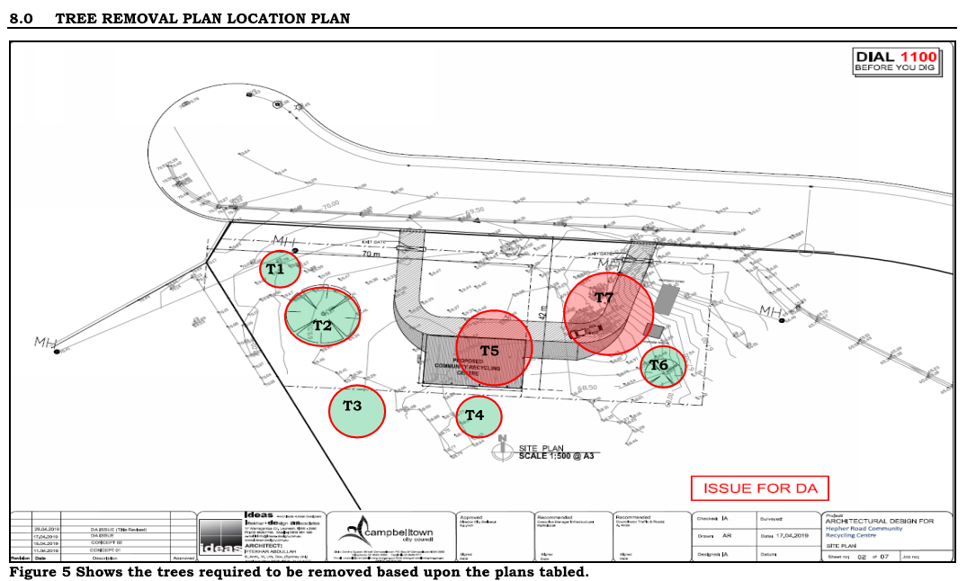
Figure 4: Tree Retention and Removal Plan

The proposed hours of operation are not finalised, and the applicant has advised that the NSW EPA Community Recycling Centres Operations and Management Handbook suggests the site be open to the public for a minimum of 2 days a week and 3 hours on a weekend. A 7 day operational period has been sought in order to maximise availability and convenience for users and the site may need to be closed to the public during bulk collection times to avoid conflict. The hours of operation put forward by the applicant are as follows:

- 7:00am to 3:00pm Thursday and Friday
- 8:00am to Midday Saturday
- Closed Monday, Tuesday, Wednesday, Sunday and Public Holidays

It is considered that there would be no inherent unreasonable impacts should the centre be opened until 5.00pm on Thursdays and Fridays or on other week days between the hours of 7.00am to 5.00pm.

The subject site of the CRC is located outside the extent of the 1% Annual Exceedance Probability flood.

Vehicles expected to access the property would include light vehicles (staff, customers and contractors), non-articulated heavy vehicles and 19 m heavy vehicles. Forklifts would also be used to relocate containers within the site.

The proposed stormwater will connect to the existing on-street stormwater pit.

The proposed development is located on an elevated area of the site to avoid impacts to flood behaviour. A flood report was submitted by the applicant which indicates that the building slab level is RL 70.00m, which is above the AEP 1% AHD RL 69.85m.

Collected rainwater would be used in the amenities building on site.

A spill containment bund is proposed to be included in the slab design.

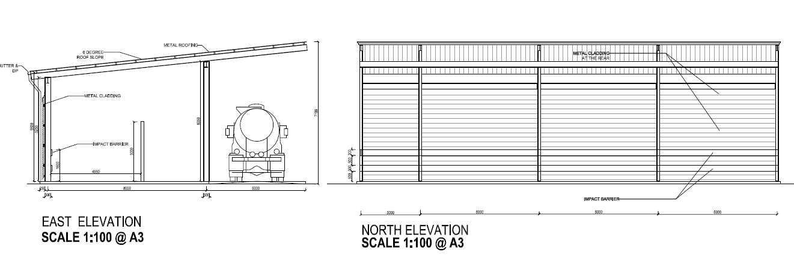
Figure 5: Elevations

The proposed landscaping comprises a mix of grass, groundcovers, shrubs and accent planting, with medium to large sized tree planting and hedging along the southern portion of the site to screen the building. The landscaping is confined within the side and rear boundary fencing and along the verge.
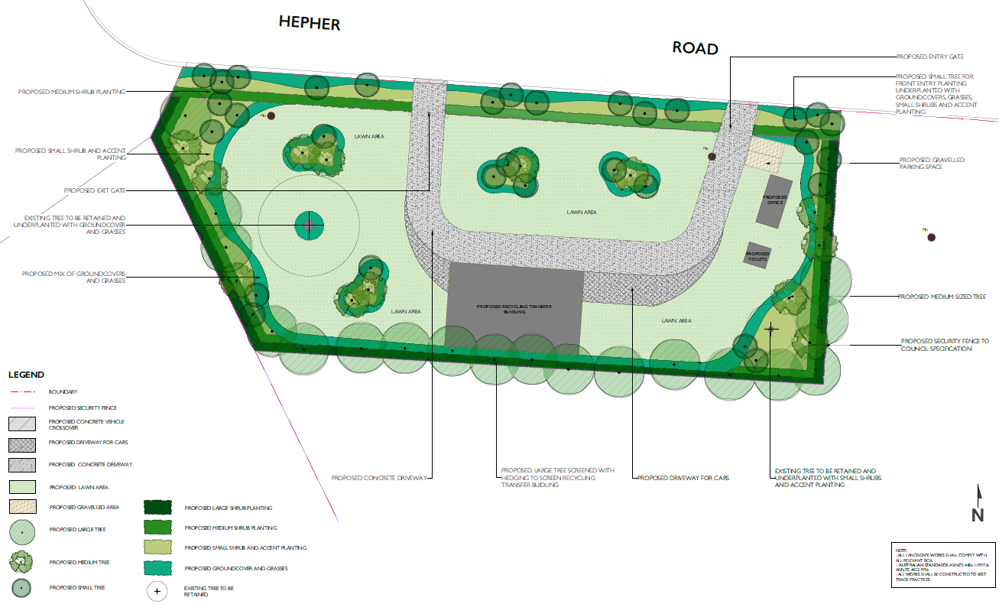
Figure 6: Landscape Plan

1.3 Site History

2465/2019/DA-S is currently under assessment by Council for the subdivision of the subject site into two allotments. The purpose of the subdivision is to allow the Community Recycling Centre proposed under this application to be situated on its own allotment 5000m² in size and be excised from the surrounding land. This subdivision application is to be reported to the Campbelltown Local Planning Panel meeting on 27 May, 2015 with a recommendation that the subdivision be approved.

  - Application History

The applicant was requested to submit additional information regarding fencing, flooding, hours of operation, tree removal and waste management.

1.5 Vision - Campbelltown 2027

Campbelltown 2027 is the Community Strategic Plan (CSP) for the city of Campbelltown. Campbelltown 2027 addresses four key strategic outcomes that Council and other stakeholders will work to achieve over the next 10 years:

• Outcome 1: A vibrant, liveable city
• Outcome 2: A respected and protected natural environment
• Outcome 3: A thriving, attractive city
• Outcome 4: A successful city
Outcome 3 is the most relevant to the proposed development.

The strategy relevant to this application is as follows:

3.2 – Ensure that service provision supports the community to achieve and meets their needs.
3.4 – Retain and expand existing businesses and attract new enterprises to Campbelltown, offering opportunities for a diverse workplace including professional, technology and knowledge based skills and creative space.

The proposed development provides a new site for the community to dispose of recycling waste. The proposal will provide for additional employment within the local community, which assists overall to contribute to the economic and employment growth in the City of Campbelltown.

Report
The development has been assessed in accordance with the matters of consideration under Section 4.15 of the Environmental Planning and Assessment Act, 1979, having regard to those matters, the following issues have been identified for further consideration.

2. Section 4.15(1)(a)(i) Any Environmental Planning Instruments

2.1 Environmental Planning and Assessment Act 1979

Clause 4.5(b) designates the consent authority as follows:

“(b) in the case of development of a kind that is declared by an environmental planning instrument as regionally significant development—the Sydney district or regional planning panel for the area in which the development is to be carried out”.

Schedule 7 of SEPP (State and Regional Development) 2011 identifies Designated Development Applications (including waste management facilities or works) as being regionally significant development and as such the Regional Planning Panel is the consent authority.
2.2 Environmental Planning and Assessment Regulation 2000

Under Clause 4 of the EP&A Act 1979, development listed in Part 1 of Schedule 3 of the Regulation is Designated Development unless it is declared not to be by a provision in Part 2 of that Schedule.

“32 Waste management facilities or works
(1) Waste management facilities or works that store, treat, purify or dispose of waste or sort, process, recycle, recover, use or reuse material from waste and—
(a) that dispose (by landfilling, incinerating, storing, placing or other means) of solid or liquid waste—
(i) that includes any substance classified in the Australian Dangerous Goods Code or medical, cytotoxic or quarantine waste, or
(ii) that comprises more than 100,000 tonnes of “clean fill” (such as soil, sand, gravel, bricks or other excavated or hard material) in a manner that, in the opinion of the consent authority, is likely to cause significant impacts on drainage or flooding, or
(iii) that comprises more than 1,000 tonnes per year of sludge or effluent, or
(iv) that comprises more than 200 tonnes per year of other waste material, or
(b) that sort, consolidate or temporarily store waste at transfer stations or materials recycling facilities for transfer to another site for final disposal, permanent storage, reprocessing, recycling, use or reuse and—
(i) that handle substances classified in the Australian Dangerous Goods Code or medical, cytotoxic or quarantine waste, or
(ii) that have an intended handling capacity of more than 10,000 tonnes per year of waste containing food or livestock, agricultural or food processing industries waste or similar substances, or
(iii) that have an intended handling capacity of more than 30,000 tonnes per year of waste such as glass, plastic, paper, wood, metal, rubber or building demolition material, or
(c) that purify, recover, reprocess or process more than 5,000 tonnes per year of solid or liquid organic materials, or
(d) that are located—
(i) in or within 100 metres of a natural waterbody, wetland, coastal dune field or environmentally sensitive area, or
(ii) in an area of high watertable, highly permeable soils, acid sulphate, sodic or saline soils, or
(iii) within a drinking water catchment, or
(iv) within a catchment of an estuary where the entrance to the sea is intermittently open, or
(v) on a floodplain, or
(vi) within 500 metres of a residential zone or 250 metres of a dwelling not associated with the development and, in the opinion of the consent authority, having regard to topography and local meteorological conditions, are likely to significantly affect the amenity of the neighbourhood by reason of noise, visual impacts, air pollution (including odour, smoke, fumes or dust), vermin or traffic.
(2) This clause does not apply to—
(a) development comprising or involving any use of sludge or effluent if—
(i) the dominant purpose is not waste disposal, and
(ii) the development is carried out in a location other than one listed in subclause (1) (d), above, or
(a1) artificial waterbodies located on relevant irrigation land, or
Note. The term relevant irrigation land is defined in clause 38.
(b) development comprising or involving waste management facilities or works specifically referred to elsewhere in this Schedule, or
(c) (Repealed)”

The proposed development falls within the category of waste management facilities or works under Schedule 3 of the Regulation due to activities which ‘sort, consolidate or temporarily store waste at transfer station or material recycling facilitates to transfer to another site for final disposal, permanent storage, processing, recycling, use or reuse and handle substances classified in the Dangerous Goods Code’, as well as being within 100m of a waterbody and 500m of a residential zone. As a result, the proposal is deemed to be Designated Development, and an EIS has been prepared in accordance with the Secretary’s Environmental Assessment Requirements (SEARs).

The Department of Planning and Environment was advised of the lodgment of the application. Subject to Council's satisfaction that the EIS suitably responds to their requirements and no submissions being received during the exhibition period relating to the proposal, no further consultation was required. No submissions were received, and it is considered that the EIS adequately responds to Council’s requirements.

2.3 Water Management Act 2000 & Water Management (General) Regulation 2018

The subject site has watercourses located in the vicinity of the developable portion of the site. The development application was lodged as Integrated Development pursuant to Section 4.46 of the Environmental Planning and Assessment Act 1979, with approval required under the Water Management Act 2000 as it involves works within 40 metres of an existing watercourse. The Natural Resources Access Regulator (NRAR) (formerly Department of Industries - Water) has reviewed the application and advised by way of a letter dated 25 November 2019 that a Controlled Activity Approval (CAA) is not required. The applicant has advised that pursuant to Clause 41 of the Water Management (General) Regulation 2018, Council as a public authority, is exempt from the requirement to gain a CAA.

NRAR has provided the following comments on the development:

- “The proposed works are located on waterfront land associated with Biriwiri Creek, a fourth order watercourse. Due consideration to the NRAR guidelines should be shown in the final design for the facility.”

An appropriate condition has been recommended in this regard.

2.4 NSW Biodiversity Conservation Act 2016 & Commonwealth Environment Protection and Biodiversity Conservation Act 1999 & Threatened Species Conservation Act 1995

The applicant has submitted a Flora and Fauna Assessment report prepared by Biosis which concludes that there is minimal or no impact upon the maintenance of biodiversity or impact upon critical habitats, threatened species, populations, ecological communities or their habitats.

The SEE indicates:

“The Local Government Area of Campbelltown is a Western Sydney interim designated areas by reference to clause 27(3) of the Biodiversity Conservation (Savings and Transitional) Regulation 2017 (BC Transitional Regs). As such, this application represents a pending or interim planning application and compliance with the Biodiversity Conservation Act 2016 is not required. The Biosis ecological assessment has therefore been prepared by reference to the former planning provisions. Pursuant to clause 27(1) of the BC Transitional Regs, the former planning provisions means ‘…the provisions of the Environmental Planning and Assessment Act 1979 that would be in force if that Act had not been amended by the new Act’.”

The OEH website states:
“Western Sydney Interim Designated Areas
The former planning provisions continue to apply to local development applications or modifications submitted before 25 November 2019 in the following western Sydney local government areas (which have been declared by the Minister for the Environment as Interim Designated Areas):

- Camden
- City of Campbelltown
- City of Fairfield
- City of Hawkesbury
- City of Liverpool
- City of Penrith
- Wollondilly”

This application was submitted before 25 November 2019 and as such the transitional provisions still apply.

The submitted Flora and Fauna Report concludes:

“Impact assessment

The proposed waste management facility will involve the following impacts to ecological features:

• Removal of 0.07 hectares of Swamp Oak Floodplain Forest EEC.
• Removal of 0.07 hectares of low quality foraging habitat for Glossy Black Cockatoo.
• Indirect impacts to Freshwater Wetlands and Green and Golden Bell Frog habitat as a result of altered hydrology.

A test of significance has been prepared to assess the potential for impacts of the proposed development on Swamp Oak Floodplain Forest and Green and Golden Bell Frog in accordance with the BC Act. A Significant Impact Criteria Assessment has also been undertaken for Green and Golden Bell Frog in accordance with the EPBC Act. These assessments are provided in Appendix 4 and Appendix 5.

The assessment determined that the development would not be considered a significant impact to Swamp Oak Floodplain Forest as it will result in the removal of 0.07 hectares of low condition vegetation. The study area contains a further 12.9 hectares of similar condition Swamp Oak Floodplain Forest, the project will result in the removal of 0.54% of the total community within the study area.

Recommendations

Given there are requirements for removal of some native vegetation including canopy trees, the focus of the following recommendations is to minimise disturbance to any surrounding native vegetation and fauna habitat. These recommendations are:

• To the fullest extent practicable, minimise disturbance to any native vegetation surrounding the study area.
• Where possible, retained trees should be protected in accordance with Australian Standard AS4970 – 2009 Protection of Trees on Development Sites, during construction, operation and decommissioning of the site compound.
• Appropriate erosion and sediment control measures should be installed surrounding the impact site to avoid sedimentation of receiving water bodies or other indirect impacts to surrounding biodiversity values.
• Temporary frog exclusion fencing should be erected to the north of Hepher Road to divert any dispersing frogs around the construction site and towards Biriwiri creek.
• In the unlikely event that unexpected threatened species are identified during the project, works should cease and an ecologist should be contacted immediately.
• Soil transportation should be minimised within, into or out of the study area to reduce the spread of weeds.
• Six priority weeds were identified within the study area (Table 4). Appropriate measures should be implemented to minimise the spread of these species.”

The proposed development was referred to Council’s Environmental experts who reviewed the Flora and Fauna Assessment and Arborist report and advised that the site is known to contain Swamp Oak open forest on riverflats of the Cumberland Plain and Hunter Valley, which is equivalent to the listed endangered ecological community (EEC) - River Flat Eucalypt Forest (RFEF) (TSC/ BC Act and Commonwealth Environment Protection Biodiversity Conservation Act, 1999). The proposed development was lodged on the 23 August 2019 and therefore comes under the savings and transitional provisions for Interim Designated Areas (IDAs). In this case, the former planning provisions apply under the NSW Threatened Species Conservation Act, 1995 and the DA is not subject to the biodiversity assessment requirements of the NSW Biodiversity Conservation Act, 2016, being the Biodiversity Offset Scheme (BOS).

It is noted that no hollow bearing trees (HBT) occur within the proposed development footprint. In summary, the development proposes to impact 0.07 ha of Swamp Oak Floodplain Forest EEC, which includes a number of canopy trees characteristic of the community, as identified in Figure 5 of the Arborist report (Horticultural Management Services, May 2020), including:

• T5: Eucalyptus tereticornis (Forest Red Gum)
• T7: Cluster of Casuarina glauca (Swamp She-Oak)

The Arborist report has provided an assessment of trees within close to proximity to the proposed development footprint. The report makes reference to both State and Federal threatened species legislation, however, fails to identify the fact the trees on site comprise RFEF, which is listed as an EEC under both the NSW BC Act and Commonwealth EPBC Act. As a consequence of this error, all of the trees identified in relation to the development footprint have been given a ‘low’ ecological significance rating even though they comprise an EEC, which would necessitate a ‘high’ ecological significance rating. For example, the stand of Casuarina glauca (Swamp She-Oak) associated with T7, is described in the Arborist report as an 8m high minor clump of regrowth swamp oaks. However, this species is in fact characteristic of the endangered RFEF community.

Conditions of consent have been recommended which allow for removal of Trees T5 and T7 only and requires tree protection measures prior to commencement of works, offset planting, weed management and updating of the landscape plan prior to issue of the construction certificate. As such, it is not envisaged that there are any ecological issues pertaining to the site.

2.5 State Environmental Planning Policy 33 – Hazardous and Offensive Development

In accordance with State Environmental Planning Policy No. 33 (SEPP 33) ­ Hazardous and Offensive Development, the proposal may be defined as a ‘potentially hazardous / offensive industry’, ‘hazardous / offensive industry’ and/or ‘hazardous / offensive storage establishment’. The applicant has considered SEPP 33 to determine whether it is necessary to undertake a Preliminary Hazard Analysis (PHA) for the development.

The EIS states:

“CRC facilities receive a number of potentially hazardous materials, which include paints (water and oil based), oils, batteries (lead and nickel cadmium), gas cylinders, fluorescent light fixtures, and smoke detectors. While measures and guidelines are in place for the safe storage of the materials, there is potential for leaks, damaged containers, or accidents that could lead to potential hazards.

CRC facilities also expect to receive non-target by-catch materials, these materials have potential to be more hazardous than the materials accepted by the facility. These by-catch materials may include items such as pesticides, metal based paints, pool chemicals, acids and alkalis.

The volumes to be stored on site would be managed via regular collection to ensure that they remain at quantities that are less than the trigger levels identified in SEPP 33 and as such a preliminary hazard analysis is not required.”

The types and quantities of materials do not exceed the threshold under the SEPP 33 Guidelines. Moreover, the SEPP 33 Guidelines stipulate that if the EPA is willing to issue a license under its pollution control legislation (Protection of Environmental Operations Act 1997), it is considered the level of offence would not be significant.

As no processing of these materials is occurring on site, and given that they will be regularly transported offsite, it is considered that the risk associated with these materials will be minimal and able to be managed appropriately. Further, as per 'Applying SEPP 33' Guidelines, where a site can comply with the EPA's licensing requirements, it is generally not considered an offensive industry.

Council Officers have contacted the EPA as part of the assessment who have advised that the application is not considered to be “Integrated Development” as the waste is only being stored on site then transferred off site.

The proposed use of the site would result in the storage of liquids including aerosol, spray paints, methylated spirits, turpentine, chlorine, acid, and thinners. The applicant has addressed the proposed storage of goods stating the volumes of the nominated goods would not exceed thresholds outlined in SEPP 33 to constitute potentially hazardous or offensive industry. Therefore, it is agreed that a Preliminary Hazard Analysis (PHA) is not required in this instance.

As such, the SEPP 33 assessment criteria has been satisfied for the purpose of this development.

2.6 State Environmental Planning Policy (Infrastructure) 2007

The purpose of the State Environmental Planning Policy (Infrastructure) 2007 is to facilitate the effective delivery of infrastructure across the state.

- Permissibility

Part 3 of the SEPP (Infrastructure) 2007 sets out prevailing development controls for certain types of developments which are considered to be significant to the State in terms of a developments’ ability to deliver a facility or service forming critical infrastructure to the region.

The subject land is zoned SP2 under Campbelltown LEP 2015 and the development of a waste management facility on SP2 zoned land is permitted with consent pursuant to Clause 121 of the State Environmental Planning Policy (Infrastructure) 2007. The use is separately defined under Clause 121 and permits the use of SP2 Infrastructure zoned land, being a prescribed zone for the purposes of the clause, for the purpose of waste or resource management. The SEPP prevails to the extent of any inconsistencies with the LEP and therefore the development is a permissible land use in the zone.

Accordingly, proposed development is a permissible land use in the zone.

- Traffic Generation

Clause 101 of the SEPP states:

“101 Development with frontage to classified road
(1) The objectives of this clause are:
(a) to ensure that new development does not compromise the effective and ongoing operation and function of classified roads, and
(b) to prevent or reduce the potential impact of traffic noise and vehicle emission on development adjacent to classified roads.
(2) The consent authority must not grant consent to development on land that has a frontage to a classified road unless it is satisfied that:
(a) where practicable and safe, vehicular access to the land is provided by a road other than the classified road, and
(b) the safety, efficiency and ongoing operation of the classified road will not be adversely affected by the development as a result of:
(i) the design of the vehicular access to the land, or
(ii) the emission of smoke or dust from the development, or
(iii) the nature, volume or frequency of vehicles using the classified road to gain access to the land, and
(c) the development is of a type that is not sensitive to traffic noise or vehicle emissions, or is appropriately located and designed, or includes measures, to ameliorate potential traffic noise or vehicle emissions within the site of the development arising from the adjacent classified road.”

Schedule 3 of the SEPP identifies circumstances where development applications should be referred to the Roads and Maritime Service for consideration. Development for the purpose of landfill, recycling facilities or waste transfer stations of any size or capacity is listed in Schedule 3. Therefore the application was referred to the Roads and Maritime Service and comments were received dated 2 March 2020. These comments raise no objection as the proposed development is unlikely to have significant impact on the state road network.

The proposed development remains acceptable with respect to traffic generation requirements of the SEPP.

2.7 State Environmental Planning Policy (State and Regional Development) 2011

The aim of this policy is to identify development that is state significant and confer functions on the Regional Planning Panel to determine certain development applications. Clause 23 of Schedule 1 of the SEPP identifies circumstances where Waste or Resource Management Facilities are considered to be classified as state significant based on its processing thresholds, that being facilities which handle more than 100,000 tonnes per year of waste or more than 1,000 Tonne per year of classified Dangerous Goods.

The development will include a limit on overall total quantities as well as the use of potentially classified Dangerous Goods, however unlikely based on the SEPP 33 review, and the thresholds are significantly below the limitations under this SEPP.

Schedule 7 of the SEPP identifies developments which are Regionally Significant Development for which the Sydney Western Regional Panel is the consent authority. The value of works is below the threshold for Council related development (Schedule 7 Section 3). Notwithstanding this, Schedule 7 of SEPP (State and Regional Development) 2011 identifies Designated Development Applications (including waste management facilities or works) as being regionally significant development and as such the Regional Planning Panel is the consent authority.

2.8 State Environmental Planning Policy 55 - Remediation of Land
SEPP No. 55 aims to provide a state-wide planning approach to the remediation of contaminated land. In particular the policy aims to promote the remediation of contaminated land in order to reduce the risk of harm to human health or any other aspect of the environment. It requires the consent authority to consider whether the subject land is contaminated when determining a development application. If the land is contaminated, the consent authority must be satisfied that the land is suitable in its contaminated state (or will be suitable, after remediation) for the purpose for which the development is proposed to be carried out.

A Phase 1 Preliminary Site Investigation (P1 PSI) dated March 2019 was undertaken over the site by Premise and identified the previous use of the site was for agricultural uses including grazing. The report concludes that the site is suitable for the proposed use and states:

“Having assessed the site against the investigation criteria documented in Section 5.2 of this P1 PSI report, and with respect to identified historic land uses, Premise considers the suitability of the site to be consistent with the proposed land use, identified as a community recycling facility, within the requirements of the NSW State Environmental Planning Policy No 55 – Remediation of Land (1998).”

The proposed development is not for residential purposes and will be for industrial use, and therefore no remediation or further investigation is required for this application. Future change of use of the site may trigger the requirement for remediation. Therefore, the information submitted with the application in regard to the suitability of the site for the proposed use remains satisfactory and considered to be suitable for the continued use as a waste management facility having regard to the provisions of the SEPP.

2.9 State Environmental Planning Policy (Vegetation in Non-Rural Areas) 2017

The State Environmental Planning Policy (Vegetation in Non-Rural Areas) 2017 works together with the Biodiversity Conservation Act 2016 and the Local Land Services Amendment Act 2016 to create a framework for the regulation of clearing of native vegetation in New South Wales.

The Policy applies to the Campbelltown Local Government Area, including (in part) land zoned for special uses. In considering the site, it is noted that it is identified in the Native Vegetation Regulatory Map as ‘Land Excluded from the LLS Act’ and does not involve the clearing of land identified in the Biodiversity Values (BV) Map as having ‘high biodiversity value’. It is concluded that the site is not subject to the Biodiversity Offsets Scheme.

Further, a Flora and Fauna report was provided.

2.10 State Environmental Planning Policy 19 – Bushland in Urban Areas

The SEPP aims to protect bushland and vegetation in urban areas the general aims of the SEPP are detailed below:

“(2) The specific aims of this policy are:
(a) to protect the remnants of plant communities which were once characteristic of land now within an urban area,
(b) to retain bushland in parcels of a size and configuration which will enable the existing plant and animal communities to survive in the long term,
(c) to protect rare and endangered flora and fauna species,
(d) to protect habitats for native flora and fauna,
(e) to protect wildlife corridors and vegetation links with other nearby bushland,
(f) to protect bushland as a natural stabiliser of the soil surface,
(g) to protect bushland for its scenic values, and to retain the unique visual identity of the landscape,
(h) to protect significant geological features,
(i) to protect existing landforms, such as natural drainage lines, watercourses and foreshores,
(j) to protect archaeological relics,
(k) to protect the recreational potential of bushland,
(l) to protect the educational potential of bushland,
(m) to maintain bushland in locations which are readily accessible to the community, and
(n) to promote the management of bushland in a manner which protects and enhances the quality of the bushland and facilitates public enjoyment of the bushland compatible with its conservation.”

As neither the subject site nor the adjoining sites are zoned for public open space, the policy does not apply to the subject site.

2.11 State Environmental Planning Policy 44 – Koala Habitat Protection

As the site exceeds 1 hectare the provisions of the SEPP apply to the proposed development. The site is not identified as containing any potential koala habitat. SEPP 44 has been addressed as part of the Flora and Fauna Assessment report which confirms the site is not core koala habitat and as such, no further consideration against SEPP 44 is required. The report states:

“The study area occurs within Campbelltown Local Government Area and as such, SEPP 44 applies. The study area supports Forest Red Gum Eucalyptus teriticornis, a Koala feed tree species as defined in Schedule 1 of the SEPP. Koala feed trees, identified above, do not make up 15 % of the total number of trees in the upper or lower strata of the tree component. Therefore the vegetation within the study area is not considered potential Koala habitat as defined under SEPP No. 44.

No further consideration is required.”

2.12 Greater Metropolitan Regional Environmental Plan No. 2 – Georges River Catchment

The proposal is within the Georges River Catchment and thus this policy applies. The general aims and objectives of this plan are as follows:

“5 Aims and objectives
(1) The general aims and objectives of this plan are as follows:
(a) to maintain and improve the water quality and river flows of the Georges River and its tributaries and ensure that development is managed in a manner that is in keeping with the national, State, regional and local significance of the Catchment,
(b) to protect and enhance the environmental quality of the Catchment for the benefit of all users through the management and use of the resources in the Catchment in an ecologically sustainable manner,
(c) to ensure consistency with local environmental plans and also in the delivery of the principles of ecologically sustainable development in the assessment of development within the Catchment where there is potential to impact adversely on groundwater and on the water quality and river flows within the Georges River or its tributaries,
(d) to establish a consistent and coordinated approach to environmental planning and assessment for land along the Georges River and its tributaries and to promote integrated catchment management policies and programs in the planning and management of the Catchment,
(e) (Repealed)
(f) to provide a mechanism that assists in achieving the water quality objectives and river flow objectives agreed under the Water Reform Package.”

To ensure sediments generated by the development will not be deposited in the Georges River Catchment via the stormwater drainage system and to ensure compliance with the relevant planning policies and strategies relating to water quality and quantity, the standard condition for the provision and maintenance of erosion and sediment control measures will be imposed. The proposal does not conflict with any of the relevant provisions of the Greater Metropolitan Regional Environmental Plan No. 2 – Georges River Catchment and is therefore considered acceptable in this regard.

The application and accompanying civil drawings include details of stormwater discharged from the site to the existing street system.

2.13 Campbelltown Local Environmental Plan 2015

Under Campbelltown Local Environmental Plan 2015, the subject site is zoned SP2 Infrastructure and identified on the maps for drainage purposes. The LEP defines the proposed use as a waste or resource management facility and as it does not explicitly permit the use of this site for the purpose of waste or resource management, it is a prohibited land use under the provisions of the local plan. However, the use is separately defined under Division 23, specifically Clause 121 of State Environmental Planning Policy (SEPP) (Infrastructure) 2007 and permits the use of SP2 Infrastructure zoned land, being a prescribed zone for the purposes of the clause, for the purpose of waste or resource management. The SEPP prevails to the extent of any inconsistencies with the LEP and therefore the development is a permissible land use in the zone.

The proposed development is considered to be consistent with the objectives of the SP2 Infrastructure zone, which are stated below:

- “To provide for infrastructure and related uses.
- To prevent development that is not compatible with or that may detract from the provision of infrastructure.
- To encourage activities involving research and development.
- To optimise value-adding development opportunities, particularly those associated with research.
- To provide for the retention and creation of view corridors.
- To preserve bushland, wildlife corridors and natural habitat.
- To maintain the visual amenity of prominent ridgelines.”

The proposed development is considered to be consistent with these objectives. The CRC is compatible use with the remainder of the land for drainage purposes and would not prevent other compatible uses on the site, subject to consent being obtained. The CRC is located on the highest portion of the site, which does not prevent the drainage purpose of the site.

The proposed CRC is supported by an EPA initiative and provides a positive environmental and social benefit to the community by reducing waste and ensuring hazardous chemicals are disposed of correctly, reducing landfill and conforming to principles of Ecological Sustainable Development.

There are no view corridors obstructed by the CRC and a well-thought-out landscaping scheme provides for screening of the proposed buildings and the centre as a whole to prevent any unsightly visual impact. The visual amenity of the area is maintained, noting that the CRC is located within an industrial estate.

Removal of vegetation is unavoidable to ensure that the small component of elevated land on the site is utilised. In order to avoid vegetation removal, works would have to be located closer to the watercourse and fill would be required. On balance, the removal of vegetation is a good planning outcome.

The development is compatible with the surrounding industrial land uses and is substantially smaller in size than the adjoining buildings.

An assessment against the relevant clauses of the CLEP 2015 is provided below:

Provision | Comment | Compliance
4.3 Height of Buildings | The site does not have height restrictions under the LEP. The proposed building has a height of 5.5m – 7.199m, which is below the considerably larger surrounding industrial buildings that have a height limit of 12m. Further, a planning proposal to increase the maximum height of buildings for industrial zoned land to 19m has been publicly exhibited. | Yes
4.4 Floor space ratio | The site and surrounding area are not subject to floor space ratio controls. | Yes
7.2 Flood Planning | This Clause applies to land below the flood planning level and has the following objectives:  “(a) to minimise the flood risk to life and property associated with the use of land,  (b) to allow development on land that is compatible with the land’s flood hazard, taking into account projected changes as a result of climate change,  (c) to avoid significant adverse impacts on flood behaviour and the environment.”  The site is partially flood affected and the development has been located on the higher ground to avoid the flood area. Flooding associated with the drainage use of the site would affect the site during a 1 in 100 year and PMF flood event. The proposed development is outside of the area of impact of the 1% AEP flood event. Subject to a minimum floor level of RL 69.85m AHD and the BCA and applicable engineering guides, the development would not result in a significant impact on flooding. | Yes
7.3 Riparian land and watercourses | This Clause is applicable to land within 30m of any waterway. The site has a number of watercourses. This Clause requires consideration of the impact upon the watercourse. The proposal involves works within 40 metres of an existing watercourse. The Natural Resources Access Regulator has advised that a Controlled Activity Approval (CAA) is not required and requested due consideration to the NRAR guidelines in the final design for the facility. An appropriate conditions have been included in this regard. | Yes

3. Section 4.15(1)(a)(ii) Any Proposed Instrument

At the time of lodgment of the development application, there were no relevant draft instruments applying to the subject land.

4. Section 4.15(1)(a)(iii) Any Development Control Plan

4.1 Campbelltown (Sustainable City) Development Control Plan 2015

The purpose of Campbelltown (Sustainable City) Development Control Plan 2015 (SCDCP 2015) is to provide more detailed provisions to supplement the Campbelltown Local Environmental Plan 2015 (CLEP 2015). Pursuant to Clause 4.15 (1) (a) (iii) Council is required to consider the relevant provisions of the applicable development control plan of the Campbelltown Local Government Area (LGA), being SCDCP 2015.

The following details the assessment of the proposal in accordance with the relevant requirements of the Campbelltown (Sustainable City) Development Control Plan 2015.

Part 2 - Requirements Applying to All Types of Development

The general provisions of Part 2 of the Plan apply to all types of development. Compliance with the relevant provisions of Part 2 of the Plan is discussed as follows:

Provision | Comment | Compliance
2.2 Site Analysis
a) The development application for all development involving the construction of a building and the Torrens title subdivision of land. | The site analysis plan submitted to Council is considered to be compliant with the requirements for a Site Analysis plan in accordance with Section 2.2 of the SCDCP 2015. | Yes
2.3 Views and Vistas
a) Development shall appropriately respond to Campbelltown’s important  views and vistas to and from public places. These include views and vistas to and from:  i) the Scenic Hills;  ii) rural/semi rural landscape areas;  iii) the Georges and Nepean River corridors;  iv) areas of significant public open space (formal and informal); and  v) heritage items. | The site is not located within an important view corridor. No important views or vistas are expected to be impacted upon by this proposal. | Yes
b) District views and existing significant view corridors as viewed to and from public places shall be protected. | Given the location of the site in the gully and the existing surrounding development, the site is unlikely to be highly visible from public places further afield. The proposed landscaping around the building reduces the visibility of the development from the surrounding area. | Yes
c) The opportunity to create new view/vista corridors shall be taken wherever possible and appropriate. | There is no opportunity to create new view corridors. | Yes
2.4 Sustainable Building Design
2.4.1 Rainwater Tanks  b) A rain water tank shall be provided for all new buildings containing a roof area greater than 100sqm for all development not specified by BASIX. The rain water tank shall have a minimum capacity in accordance with Table 2.4.1. | Based on the roof area of the proposed development, the proposed development requires a rainwater tank and a 5000L tank is proposed and conditioned. | Yes
c) All rainwater tanks shall comply with AS3500 (as amended) - National  Plumbing and Drainage Code Guidelines for Plumbing Associated with Rainwater  Tanks in Urban Areas and Sydney Water’s Guideline for Rainwater Tanks on Residential Properties. | The installation of the rainwater tank will be appropriately conditioned to satisfy the requirements of the SCDCP. | Yes
d) The rainwater tank incorporated in new  commercial and industrial development exceeding 5,000sqm shall be connected  to the plumbing in the building to provide water for toilets. | The proposed rainwater tank will be plumbed for reuse within the building for toilet flushing and watering landscaping. | Yes
f) Above ground water tanks shall be located behind the primary or secondary building line. | The rainwater tanks are not located above ground level. | Yes
2.4.2 Solar Hot Water  a) All new buildings are encouraged to provide a solar hot water system.  b) Where the site is connected to the gas main, the solar hot water system is encouraged to  be gas boosted. | The proposed development is not considered to require a solar hot water system. | Yes
2.4.3 Natural Ventilation  a) The design of new buildings shall be encouraged to maximise opportunities for cross flow ventilation, where practical, thus minimising the need for air conditioning. | The proposed partially open building allows for passive ventilation systems. | Yes
2.4.4 Light Pollution  a) Outdoor lighting shall be designed to minimise pollution from the unnecessary dispersion  of light into the night sky and neighbouring properties. | The proposed development will be appropriately conditioned to ensure outdoor lighting does not affected surrounding residential properties. Notwithstanding, a condition of consent will be included to address light spill on adjoining residential properties and limit the hours of illumination of signage. | Yes
2.5 Landscaping
a) Landscape design shall enhance the visual character of the development and complement the design/use of spaces within and adjacent to the site. | The landscape plan submitted seeks to enhance the landscape character of the site and assists in softening built form. | Yes
b) Landscape design shall retain and enhance the existing native flora and fauna characteristics of a site wherever possible. | Replacement planting will be provided to the site as part of the landscape scheme. Conditions of consent have been recommended which allows for remove of Trees T5 and T7 only and requires tree protection measures prior to commencement of works, offset planting, weed management and updating of the landscape plan prior to issue of the construction certificate. | Yes
c) Landscape design shall add value to the quality and character of the streetscape.  d) A Landscape Concept Plan is required to be submitted with a development application for:  xi) commercial development;  xii) industrial development; | The applicant has submitted a landscape plan, that includes substantial landscaping to all frontages with a variety of trees, shrubs and ground covers. | Yes
e) The Landscape Concept Plan shall illustrate mature height, spread of species, trees to be removed/retained and shall be prepared by a suitably qualified person. | The landscape plan details the mature height and species. | Yes
f) Landscaping shall maximise the use of locally indigenous and other drought tolerant native plants and avoid the use of invasive species. | The plant species selected is consistent with the Native Gardening Guide for Campbelltown Local Government Area, which includes locally indigenous and drought tolerant plant species. | Yes
2.7 Erosion and Sediment Control
a) An Erosion and Sediment Control Plan (ESCP) shall be prepared and submitted  with a development application  proposing construction and/or  activities involving the disturbance of the land surface. For requirements relating to the preparation of an ESCP, refer to Appendix 5 of Volume 1 and Council’s Engineering Design Guide for Development. | The applicant has submitted an erosion and sediment control plan in support of the proposed development. The submitted plan satisfies the requirements of the SCDCP and the plan will be endorsed as a consent document, as well as conditions of consent. | Yes
b) Site activities shall be planned and managed to minimise soil disturbance. | Site activities shall be managed to minimise disturbance. | Yes
c) Catch drains or diversion banks shall be designed and constructed to divert water  around any area of soil disturbance. | Suitable measures are included in the ESCP to maintain water quality. | Yes
d) All stockpiles shall be located within the sediment control zone and shall not be located within an overland flow path. | The location of stockpiles shall be conditioned to comply with the control. | Yes
2.8 Cut, fill and floor levels
2.8.1 Cut and Fill  a) A Cut and Fill Management Plan (CFMP) shall be submitted with a development application where the development incorporates cut and/or fill operations. | The proposed development does not include significant cut or fill. | N/A
c) Any excavation within the zone of influence of any other structure requires a ‘dilapidation report’ (prepared by a suitably qualified person) demonstrating that adequate ameliorative measures are to be implemented to protect the integrity of any structure. | The proposed development does not include significant cut or fill. | N/A
d) Development incorporating any cut or fill shall comply with the following requirements:  i) minimum cross fall of 1% to any adjoining waterway; and  ii) batters to be no steeper than 2H:1V (‘H’ stands for the term ‘horizontal distance’ and ‘V’ stands for the term ‘Vertical distance’;  iii) batters to be no steeper than 6H:1V for public areas. | The proposed development does not include significant cut or fill. Any minor fill is capable of satisfying these requirements. | Yes
e) All fill shall be ‘Virgin Excavated Natural Material’ (VENM). | The proposed development does not include significant cut or fill. Any minor fill is to be VENM. | Yes
f) No fill shall be deposited in the vicinity of native vegetation. | There is limited vegetation is present on site and ample opportunity to locate fill away from vegetation. | Yes
2.8.2 Surface Water and Floor Levels  a) Development shall not occur on land that is affected by the 100-year ARI event unless the development is consistent with the NSW Floodplain Development Manual. | The site is partially flood affected. The proposal is consistent with the NSW Floodplain Development Manual and conditions imposed. Flooding associated with the drainage use of the site would affect the site during a 1 in 100 year and PMF flood event. The proposed development is outside of the area of impact of the 1% AEP flood event. Subject to a minimum floor level of RL 69.85m AHD and the BCA and applicable engineering guides, the development would not result in a significant impact on flooding. | Yes
b) All development on land affected by stormwater flow from main stream, local creek or over land flow shall satisfy the relevant fill and floor level requirements as specified in Table 2.8.1. | As above. | Yes
c) All development shall have a ground surface level, at or above a minimum, equal to the 100-year ‘average recurrence interval’ (ARI) food level. | As above. | Yes
d) For development on land not affected by an overland flow path the minimum height of the slab above finished ground level shall be 150 mm, except in sandy, well-drained areas where the minimum height shall be 100mm. These heights can be reduced locally to 50mm near adjoining paved areas that slope away from the building in accordance with AS 2870 (Residential Slabs and Footings Construction). | Not applicable. | N/A
2.10 Water Cycle Management
2.10.1 Water Cycle Management  a) A comprehensive Water Cycle Management Plan (WCMP) shall be prepared and submitted as part of a  development application. | The stormwater design is in accordance with the Engineering Design Guide. The application was referred to Council’s Development Engineer, who review the proposal and applied relevant conditions of consent. | Yes
2.10.2 Stormwater  a) All stormwater systems shall be sized to accommodate the 100- year ARI event (refer to Section 4 of Council’s Engineering Design Guide for Development. | As above. | Yes
b) The design and certification of any stormwater system shall be undertaken by a suitably qualified person. | The plan was prepared by a suitably qualified engineer. | Yes
d) Development shall not impact on adjoining sites by way of overland flow of stormwater unless an easement is provided. All overland flow shall be directed to designated overland flow paths such as roads. | Overland flow is not directed onto adjoining properties. | Yes
g) A major/minor approach to drainage is to be taken for stormwater flows. Generally the piped drainage system shall be sized to accommodate the difference between the 100-year ARI flow and the maximum safe overland flow, with minimum requirements as set out in section 4 of Council’s Engineering Design Guide for Development. | As above. | Yes
h) Stormwater collected on a  development site shall be disposed of (under gravity) directly to the street or to another Council drainage system/device. Where stormwater cannot be discharged directly to a public drainage facility, a drainage easement of a suitable width shall be created over a downstream property(s) allowing for the provision of a drainage pipe of suitable size to adequately drain the proposed development to a public drainage facility. | The applicant has submitted a stormwater plan. | Yes
i) All proposed drainage structures incorporated within new development shall be designed to maintain public safety at all times. | The drainage structures are designed to maintain public safety. | Yes
j) Development shall not result in water run-off causing flooding or erosion on adjacent properties. | The runoff from the proposed development is not considered to result in flooding to adjoining properties. | Yes
k) Stormwater run-off shall be  appropriately channelled into a  stormwater drain in accordance with Council’s Engineering Design Guide for Development. | The stormwater runoff shall be channelled into Council’s system. | Yes
2.10.3 Stormwater Drainage  a) A stormwater Drainage Concept Plan shall be prepared by a suitably qualified person, and submitted with all development applications, involving construction (except for internal alterations/fitouts), demonstrating to Council how the stormwater will be collected and discharged from the site. | The applicant has submitted a stormwater plan which was referred to Council’s Development Engineer for review and appropriate conditions of consent have been recommended. | Yes
b) The stormwater concept plan shall include the following information as a minimum:  i) locations, layouts and sizes of  stormwater pipes and pits;  ii) minimum grades and capacity of stormwater pipes; and  iii) existing and proposed easements, site contours and overland flow path/s. | The applicant has submitted a stormwater management plan. | Yes
2.11 Heritage Conservation
2.11.1 Aboriginal Heritage  a) All developments that have the potential to impact upon Aboriginal cultural heritage must provide an assessment in accordance with the “Due Diligence Code of Practice for the Protection of Aboriginal Objects in NSW”, published  by the Office of Environment and  Heritage (OEH). This requires an initial investigation of the potential impact of a development on Aboriginal Cultural Heritage in circumstances where the proposed development involves  disturbance to cultural sites (eg.  Aboriginal culturally modified trees), or the ground surface. This initial investigation is to be undertaken by the applicant and requires an assessment of  whether there are:  i) any known Aboriginal sites within the development site (determined by undertaking a search of the Aboriginal Heritage Information Management System (AHIMS)  database (which is maintained  by the Office of Environment and Heritage); and/or  ii) any other sources of relevant  information of which a person is  already aware; and/or  iii) Whether the development is on a site that is not disturbed land and is:  – within 200m of waters, or  – located on a ridge top, ridge line or headland, or  – located within 200m below or above a cliff face, or  – within 20m of/or in a cave, rock shelter, or a cave mouth. | An aboriginal review by the applicant and AHIMS search did not identify any Aboriginal Sites of Places either within the site or within a 50m buffer of the site. | N/A
b) Where the initial investigation confirms the presence or likely presence of Aboriginal objects or the above landscape features, further assessment  and visual inspection must be conducted in accordance with the “Due Diligence Code of Practice for the Protection of  Aboriginal Objects in NSW” by a person with expertise in Aboriginal cultural heritage management. | An aboriginal review by the applicant and AHIMS search did not identify any Aboriginal Sites of Places within a 50m buffer of the site. | N/A
c) If this assessment indicates that there are, or are likely to be, Aboriginal objects, and/or an Aboriginal Place in the area of the proposed activity, more detailed investigation and an  impact assessment shall be required and must be prepared by a person with expertise in Aboriginal cultural heritage  management. Where it is determined that harm could occur to Aboriginal objects then an Aboriginal Heritage Impact Permit application must be  made to the OEH (and be approved prior to works occurring). | An aboriginal review by the applicant and AHIMS search did not identify any Aboriginal Sites of Places within a 50m buffer of the site. | N/A
d) The assessment shall be prepared in accordance with the following documents:  i) Due Diligence Code of Practice for  the Protection of Aboriginal Objects in NSW (2010);  ii) Code of Practice for Archaeological Investigation of Aboriginal Objects in New South Wales (2010); and  iii) Aboriginal cultural heritage  consultation requirements for  proponents 2010. Part 6 National Parks and Wildlife Act 1974 (2010). | An aboriginal review by the applicant and AHIMS search did not identify any Aboriginal Sites of Places within a 50m buffer of the site. | N/A
e) The assessment shall take into account the following documents:  i) Operational Policy: Protecting  Aboriginal Cultural Heritage  (February 2009);  ii) OEH Guide to investigating,  assessing and reporting on  Aboriginal cultural heritage in NSW (2011). | An aboriginal review by the applicant and AHIMS search did not identify any Aboriginal Sites of Places within a 50m buffer of the site. | Yes
2.11.2 Heritage  Design Requirements  a) Any development application made in respect to development on land that is:  i) occupied by a heritage item; or  ii) adjoining land occupied by a  heritage item; or  iii) located within a heritage  conservation area,  shall provide a Statement of Heritage Impact (SHI) that assesses the impact  of the proposed development on the heritage significance, visual curtilage and setting of the heritage item or conservation area. | The site does not contain a heritage item and is not within a heritage conservation area. | Yes
b) Any development on land occupied by an item of heritage, or land located within a heritage conservation area shall be designed by a suitably qualified  person and have regard to the provisions of any relevant study or Conservation Management Plan (CMP). | The site does not contain a heritage item and is not within a heritage conservation area. | N/A
c) Unless otherwise advised by council, a Conservation Management Plan (CMP)  shall be required for all proposed development involving the adaptive reuse of a heritage item, or major alterations and additions. | The site does not contain a heritage item and is not within a heritage conservation area. | N/A
2.13 Security
a) Development shall be designed to:  i) maximise, where possible,  casual surveillance opportunities to the street and surrounding public places;  ii) minimise dead ends and other possible entrapment areas;  iii) clearly identify and illuminate  access points to buildings and  designated public places; and  iv) clearly differentiate between  private and public space.  b) External lighting shall be designed to:  i) encourage the use of safe areas;  ii) define safe corridors for movement of people; and  iii) allow facial recognition of  approaching pedestrians at 15  metres.  c) Development shall incorporate appropriate landscaping, fencing and  security devices to assist in crime prevention.  d) Commercial and industrial buildings that are not secured from public access after close of business shall have external finishes that are graffiti  resistant.  e) Development applications for multi dwelling housing, attached dwellings residential fat buildings, mixed-use development, boarding houses, shop top housing, commercial development, industrial development and large  scale subdivision comprising more than 10 dwellings/units allotments or incorporating works to be dedicated  to Council shall be accompanied by a crime prevention plan to be prepared  by a suitably qualified person addressing how the development embraces the  principles of Crime Prevention Through Environmental Design. | The applicant has addressed crime prevention in the EIS submitted to Council, including surveillance, access control, territorial reinforcement and activity management.  The proposed development includes landscaping, fencing and lighting to prevent crime on the property.  The proposed development is for a single building. The applicant has not provided a crime prevention plan for the proposed development; however, the information detailed in the EIS is considered sufficient for the proposed use. | Yes
2.14 Risk Management
2.14.1 Contaminated Land  a) The requirements of Managing Land Contamination Planning Guidelines, SEPP 55 – Remediation of Land (EPA,  DUAP, 1998) shall be satisfied on sites known to have, or may give Council reason to suspect, a potential for previous contamination. | The applicant has submitted a Phase 1 preliminary site investigation and the land has been deemed suitable for the proposed use. | Yes
b) An initial investigation regarding the possible or actual contamination of a site shall be carried out by a suitably qualified person. | The applicant has submitted a Phase 1 preliminary site investigation and the land has been deemed suitable for the proposed use. | Yes
c) Where a site is identified by Council, Office of Environment and Heritage and/or by the initial investigation as being, or having the potential to be contaminated, a Contamination  Management Plan shall be submitted with the development application. | The site is not identified as being contaminated. | N/A
2.14.2 Salinity  Design Requirements  a) Any development:  i) within 50 metres of the top of the bank of a watercourse;  ii) located in an area that has bare soil patches or salt scalds;  iii) occupied by soils that appear  ‘puffy’ when dry, or greasy when wet;  iv) located in an area that is occupied by salt tolerant plant species;  v) located in an area that has  white staining on nearby house  foundations or walls; or  vi) located on soils that are derived from Wianamatta Shale; shall be designed in accordance with Section 5.8 Council’s Engineering  Design Guide for Development | No salinity issues have been identified on the site. Notwithstanding this, standard advice will be included with the development consent with regard to salinity. | Yes
b) A detailed Salinity Analysis and Remedial Action Plan shall be prepared and submitted with the development application if:  i) the site has been identified as being subject to a salinity hazard; or  ii) an investigation reveals that the land is saline. | Not applicable. | N/A
2.14.3 Bushfire  a) Development shall be designed and located so as to minimise the risk of loss  of life or property from bushfire. | The site is not identified as being bushfire affected. | N/A
2.14.4 Subsidence  Design Requirements  a) Any development on a site located within South Campbelltown Mine Subsidence  District, or Appin Mine Subsidence District may be at risk of the effects of subsidence from past and/or future underground mining. An appropriate engineering outcome shall be achieved. | The site is not located within a mine subsidence area. | N/A
2.14.5 Public Health  a) Cooling towers shall be located in accordance with the requirements of  the following standards:  i) Australian Standard No. AS/  NZS 3666 Part 1, Air-Handling  and Water Systems of Buildings-Microbial  Control Installation and  Commissioning (as amended).  ii) Australian Standard No. AS/  NZS 3666 Part 2, Air-Handling  and Water Systems of Buildings-Microbial  Control Operation and  maintenance (as amended).  iii) Australian Standard No. AS/  NZS 3666 Part 3, Air-Handling  and Water Systems of Buildings-Microbial  Control Performance-based  maintenance of cooling  water systems (as amended). | Not applicable. | N/A
2.15 Waste Management
2.15.1 Waste Management Plan  a) A detailed Waste Management Plan (WMP) shall accompany development applications for certain types of development/land uses, as detailed in Table 2.15.1 and for any other development that in the opinion of Council a WMP is required. | The applicant has submitted a waste management plan which addresses operational waste management.  The applicant has indicated that an operational environmental management plan would be developed to outline the ongoing management and operation of the site and this would be supplied prior to operations commencing. | Yes
c) Plans submitted with a development application shall detail the following (as applicable):  i) the size and location of waste and recycling storage areas;  ii) routes for occupants to access waste and recycling areas;  iii) collection point and/or access route for collection vehicles;  iv) ventilation of waste and recycling storage areas;  v) location of garbage chute and  service rooms;  vi) bin and storage area washing facilities; and | The location of waste and recycling is indicated on the plans. Given the nature of the proposed use, bin washing facilities are not considered to be required for the proposed development. | Yes
2.15.2 Waste Management during demolition & construction  a) All waste and recyclable streams shall be stored separately on site. | A Waste Management Plan (WMP) was provided.  The applicant has indicated that this is provided for by the CRC model and the site would be operated in accordance with the EPA Operations and Management Handbook (2nd Edition), or version as current. | Yes
b) All storage areas/containers for each waste and recycling stream shall be kept on the site at all times and shall be indicated on the site plans/drawings as part of the WMP. | As above. | Yes
c) Where material cannot be reused or recycled, it shall be disposed of at an appropriately licensed waste management facility. Details of disposal arrangements shall be specified in the WMP. | As above. | Yes
d) Convenient and safe vehicular access to waste and recycling material storage areas shall be provided. | Indicated on the plans. | Yes
e) The removal, handling and disposal of asbestos or other hazardous materials shall be carried out in accordance with  WorkCover NSW, Office of Environment and Heritage and other regulatory authority guidelines and requirements. | Given the nature of the existing site conditions and the proposed development, removal and disposal of asbestos waste is not considered to be applicable. | N/A
2.15.3 On-going Waste Management  a) Provision shall be made for all waste and recycling storage containers to be located behind the primary and secondary building line and out of public view.  b) Any room(s) for storing garbage and recycling shall be located in a position that is convenient for occupants and  waste collection staff. Collection rooms shall complement the development and not be visibly obtrusive when viewed  from any public place.  c) A refuse collection point shall be nominated demonstrating that waste-loading operations can occur on a level surface not adjacent to steep gradients,  vehicle ramps and pedestrian access points.  d) The path for wheeling bins between waste storage area(s) and the collection vehicle shall be free of steps or kerbs and  have a maximum gradient of 1V:8H.  e) The maximum travel distance between any storage area/point and the collection point for all bins shall be 25 metres.  f) Where it is intended that collection vehicles are to drive into a private property to collect waste and recycling, the development shall be designed to provide for:  i) the safe and efficient service of the development with minimal need to reverse;  ii) vehicles to enter and exit in a  forward direction;  iii) adequate clearance to  accommodate the waste collection vehicle dimensions detailed in Table 2.15.2.  iv) where collection vehicles are  required to enter the property, the pavement shall be constructed in such a manner that will not be damaged by a collection vehicle carrying the maximum legal weight. | Indicated on the plans and details in the application. A Waste Management Plan (WMP) was provided and operational waste management will be further developed. | Yes
2.16 Provision of Services
The pavement shall be constructed in such a manner that will not be damaged by a collection vehicle carrying the maximum legal weight. | Details on engineering plans. | Yes
2.16.2 Electricity  a) Details of the proposed method of power supply shall be provided as part of the development application for any development involving the construction of a building within rural and environmental protection zones. | The site is not located within a rural or environmental protection zone. | N/A
b) Any structure associated with the provision of electricity shall not result in any adverse impacts on the natural environment and/or adjoining  properties. | The development can be serviced by electricity without impact on adjoining properties or the environment. | Yes
2.17 Work On, Over or Near Public Land
2.17.1 Approval Required Prior to Working On or Over Public Land  a) Written approval shall be obtained from Council, prior to the commencement of any works, activities or occupancy  upon public land, including roads, road related areas, stormwater connections, Council car parks, footpaths or nature strips. | Appropriate approvals will be obtained by the applicant should the development require any works on public land, roads or the like. | Yes
2.17.2 Working Near Public Land  a) Not withstanding clause 2.17.1 a) a hoarding or fence shall be erected between the work site and a public  place where:  i) the work involved in the  development is likely to cause  pedestrian or vehicle traffic in a  public place to be obstructed or  altered; and/or  ii) the building involves the enclosure of a public place in accordance  with Work Cover requirements | Appropriate approvals will be obtained by the applicant should the development require any works on public land, roads or the like. | Yes
b) Where a hoarding fence is required to be erected upon public land, including any road, road related area, footpath  or nature strip, prior written approval shall be obtained from Council. | Appropriate approvals will be obtained by the applicant should the development require any works on public land, roads or the like. | Yes
c) Where the site work is likely to be hazardous to persons on a public place, the work site shall be kept lit between the sunset and sunrise. | Not applicable. | N/A
2.19 Development Near or on Electricity Easements
 | There are no easements nominated on the deposited plan. | Yes
2.20 Development on Land Adjacent to, of Affected by a Gas Easement
 | There are no easements nominated on the deposited plan. | Yes

Part 11 – Vegetation and Wildlife Management

The site includes limited vegetation, and the vegetation mapping on the site identifies vegetation as exotic or weeds. The applicant has submitted a Flora and Fauna Assessment report which concludes that there is minimal or no impact upon the maintenance of biodiversity or impact upon critical habitats, threatened species, populations, ecological communities or their habitats. Council previously cleared the site in anticipation of the culvert works and to facilitate future development, with the exception of scattered trees and weeds in the south-western corner.

5. Section 4.15(1)(a)(iiia) Any Planning Agreement that has been entered into under Section 93F, or any draft planning agreement that a development has offered to enter into under Section 93F

No planning agreement is proposed with regard to the subject application.

6. Section 4.15(1)(a)(iv) The regulations

Under Clause 4 of the EP&A Act 1979, development listed in Part 1 of Schedule 3 of the Regulation is ‘Designated Development’ unless it is declared not to be by a provision in Part 2 of that Schedule.

The proposed development falls within the category of waste management facilities or works under Schedule 3 of the Regulation due to activities which include ‘sort, consolidate or temporarily store waste at transfer station or material recycling facilitates to transfer to another site for final disposal, permanent storage, processing, recycling, use or reuse and handle substances classified in the Dangerous Goods Code.’ As a result, the proposal is deemed to be ‘Designated Development’, and an EIS has been prepared in accordance with the Secretary’s Environmental Assessment Requirements (SEARs).

The Department of Planning was advised of the lodgment of the application. Subject to Council's satisfaction that the EIS suitably responds to their requirements and no submissions being received during the exhibition period relating to the proposal, no further consultation was required.

7. Section 4.15(1)(b) The likely impacts of development

The likely impact of the development has been considered extensively in the assessment of the proposed development against the relevant controls. The proposal is suitable having regard to its context, impact upon the natural and built environment and surrounding land uses. The proposal is likely to have a positive social and economic impact and is suitably located within an existing industrial estate with good vehicular access via the existing road network and separation to residences nearby.

Contamination

The site has been reviewed in terms of contamination and deemed suitable for the proposed use.

Water & Drainage

An extensive review with respect to stormwater and drainage, as well as traffic and vehicular access has been undertaken by Council’s Engineers. The information that has been received from the applicant is sufficient to be satisfied that the proposed development is suitable. Stormwater would be managed on site to ensure that post development off site flows match or improve on pre-development levels

A Soil and Water Management Plan, which also addresses flooding, and detailed drainage plan is required to be submitted to the satisfaction of the certifying authority prior to the release of the construction certificate, to ensure consistency with local and state government legislation, standards, codes, guidelines and best practice.

Flooding

An assessment of potential flooding impacts confirms that the proposed development is outside of the area of impact of the 1% AEP flood event. Subject to implementation of a minimum floor level of RL 69.85 m AHD and development of the building in accordance with the requirements of Clause 3.1.2.3 of Volume 2 of the Building Code of Australia and Section 4.5 of the Engineering Design Guide for Development, the assessment finds that the development would not result in a significant impact.

Vehicular Access & Traffic Impacts

The CRC will be accessed via separate entry point and exit via second access point to ensure vehicular movement is in a one-way direction and is free flowing. The site has frontage to Hepher Road and is accessed via an intersection at Johnson Road, which is a Collector Road. The local road network connects to the Hume Motorway to the north.

The EIS states:

“The CRC is expected to receive 50 vehicular movements a day, with 5 of those during peak hour. This results in an estimated 839 daily peak hour vehicle movements along Hepher Road.”

The application indicates the vehicles using the site would include light vehicles (staff, customers and contractors), non-articulated heavy vehicles and 19 m heavy vehicles.

The RMS advised via letter dated 2 March 2020 which raises no objection as the proposed development is unlikely to have significant impact on the state road network.

Council’s Engineers have raised no objection to the proposal and have provided appropriate conditions of consent.

The existing intersection is capable of withstanding the additional traffic movements generated by the proposed CRC.

Compatibility of Development & Visual

The development is compatible with the existing surrounding industrial land uses and minimal change is proposed to the existing landscaping or streetscape given the small scale of the development and the proposed landscape screening. The proposal is smaller in size and considerably less visually dominant than the other industrial developments in the locality.

Ecological Sustainable Development

The CRC is an EPA initiative to reduce waste and ensure hazardous chemicals are disposed of correctly. Immobilizes contaminated materials prior to being disposed to landfill thus conforming to principles of Ecological Sustainable Development (ESD). The nearest CRC is located at Liverpool, approx. 20 km from the proposed site. The provision of a local resource that is accessible to residents assists to ensure that problem waste is diverted from residential waste streams and from ending up in landfill.

Operational Environmental Management Plan

The applicant will prepare an Operational Environmental Management Plan to address appropriate mitigation measures in regard to Air Quality, Waste Management, Spill Management, Traffic Management, Stormwater Management and Noise Management. Consultation with the relevant authorities, where required, was stipulated in conditions.

Hours of Operation

The NSW EPA Community Recycling Centres Operations and Management Handbook suggests the site be open to the public for a minimum of 2 days a week and 3 hours on a weekend. The applicant has indicated that a 7 day operational period is ideal in order to maximise availability and convenience for users, other than closure to the public during bulk collection times to avoid conflict. The hours of operation put forward by the applicant are as follows:

• 7:00am to 3:00pm Thursday and Friday
• 8:00am to Midday Saturday
• Closed Monday, Tuesday, Wednesday, Sunday and Public Holidays

The indicated hours of operation are suitable given the location within an industrial estate and distance to nearby residences of approximately 300 m to the south west of the subject portion of the site. The information submitted with the application and its location within an industrial area and removed from any residential premises means that conditions limiting the hours of operation to those proposed by the applicant are not necessary. Instead, a more general range of operating hours is considered reasonable so that should the operator seek to change the opening day from one to another or seek to change the opening hours to slightly later in the day, eg 4.00pm, an application to modify the consent is not required.

Risk Assessment

The EIS includes a risk assessment in order to characterise the environmental risks associated with the proposed CRC operations and identify any necessary mitigation measures. The areas identified as medium to high risks have been addressed in the EIS and accompanying specialist reports.

Development Contributions

Council’s Contribution Officer advised that no contribution is applicable as the application is for public infrastructure which is exempt under Clause 2.7(4) of CLIP 2018.

8. Section 4.15(1)(c) The Suitability of the Site for the Development

The subject site is suitably zoned for the proposed CRC development. The design and siting of the buildings is considered responsive to the site attributes and the development is responsive to the desired character of area in accordance with the zone objectives.

9. Section 4.15(1)(d) Any Submissions Made in Accordance with This Act or the Regulations

Part 9 of Campbelltown (Sustainable City) Development Control Plan 2015 outlines Council’s public participation policy in regard to Council Strategic Planning Documents (CSPDs) and Development Applications (DAs).

The policy requires applications proposing specified land uses and construction on land adjoining allotments where residential development is permissible to be publicly notified. The subject application proposes construction of a Community Recycling Centre with residential approx. 300 m to the south west of the subject portion of the site and as such was required to undergo the notification process.

The application was publicly exhibited and notified to the surrounding property owners by way of a letter and accompanying plans. The application was placed on exhibition from 15 August to 19 September 2019 to provide the opportunity for comments regarding the proposal. Additionally, the application was sent to the Department of Planning for exhibition. No submissions were received in regard to the proposed development.

10. Section 4.15(1)(e) The Public Interest

Having regard to the issues discussed in the assessment report and those identified in the submission, it is considered that the proposed development is in keeping with the public interest.

Referrals

Development Engineers
The proposed development was referred to Council’s Development Engineer, who reviewed the proposed development and imposed conditions of consent.

Environment
The proposed development was referred to Council’s environmental experts, who reviewed the Flora and Fauna Assessment and Arborist report, who reviewed the proposed development and imposed conditions of consent and the comments are detailed elsewhere in this report. Conditions of consent have been recommended which allows for remove of Trees T5 and T7 only and requires tree protection measures prior to commencement of works, offset planting, weed management and updating of the landscape plan prior to issue of the construction certificate.

Property
The proposed development was referred to Council’s Property Department, who reviewed the proposed development and raised no concerns, but did request the subdivision of the proposed waste facility from the remainder of the site. A development application for the subdivision of the site (application No. 2465/2019) is currently under consideration and will be reported to the Campbelltown Local Planning Panel meeting on 27 May 2020 for determination.

Contamination
The proposed development was referred to Council’s Contamination expert and further information as provided regarding waste management to ensure that the SEARs were satisfied. The proposed development was reviewed, and conditions of consent imposed.

Contributions
Council’s Contribution Officer advised that no contribution is applicable as the application is for public infrastructure which is exempt under Clause 2.7(4) of CLIP 2018.

Roads and Maritime Service (RMS)
The application was referred to RMS, the comments are detailed elsewhere in this report. Advice was received via letter dated 2 March 2020 which raises no objection as the proposed development is unlikely to have significant impact on the state road network.

Natural Resources Access Regulator (previously Office of Water)
The application was referred to Natural Resources Access Regulator, the comments are detailed elsewhere in this report. Advice was received via letter dated 25 November 2019 indicating that a controlled activity approval is not required and no further assessment by this agency is necessary. A condition is included regarding compliance with NRAR guidelines, as outlined within the letter.

Office of Environment and Heritage
Office of Environment and Heritage advised that they do not need to review the aboriginal due diligence assessment.

Department of Planning and Environment
The Department of Planning and Environment was advised of the lodgment of the application. Subject to Council's satisfaction that the EIS suitably responds to their requirements and no submissions being received during the exhibition period relating to the proposal, no further consultation was required.

11. Conclusion

The development application 2117/2019/DA-DE proposes construction of a Community Recycling Centre at Lot 104 DP 1056782, Hepher Road, Campbelltown. The proposal has been assessed under Section 4.15 of the Environmental Planning and Assessment Act 1979.

It is considered that the overall social and economic impacts of the proposed development would be positive, and that potential impacts on the natural and built environments have and will be mitigated through design measures and conditions of consent.

The application was publicly exhibited and notified to surrounding residents, and no submissions were received.

The site’s location, zoning and existing land use make it suitable for the proposed development, and the proposal is considered to be in the broad interests of the general public.

The proposal is largely compliant with the relevant development standards and controls.

Therefore, the proposal is recommended for approval.

12. Officer's Recommendation
That development application 2117/2019/DA-DE proposing the construction of a Community Recycling Centre at Lot 104 DP 1056782, Hepher Road, Campbelltown be approved subject to the conditions outlined in Attachment 1.

